|  |  |  |  |
| --- | --- | --- | --- |
| Ahsanullah University of Science and Technology | | | |
| Department of Computer Science and Engineering | | | |
|  |  | |  |
|  | | | |
| Project Name : | | **Car Parking System Management** | |
| **Couse Name:** | | Database Lab | |
| **Couse ID:** | | CSE 3104 |  |
| **Semester :** | | FALL 2018 |  |
|  | |  |  |
| **Group : 06** | | Name: Md. Zahid Fesabelilla | |
|  | | ID : 160204082  Name : Arafath Hossain  ID : 160104029 (re-ad) | |

**Introduction:**

Our project is “Car Parking System Management” which provides a user friendly interface . User (driver) and owner will sign up/Log in differently . Owners will give their parking slot details and users will search for parking slots by area/sector/road no . One slot will be booked for only one user at a time . Payments will be in cash between the user and the owner . User can see their history and the owner can also see their parking slot status and the developers can see the whole booking history. Both have logout option.

**Motivation and Objective:**

Our first goal is the integration of google map in our project . Then we have a plan to build an android app for this project . After that , we will ensure better user experience by showing them the suggestion for better slots near them . Both the user and the owner will be provided a rating system . Sooner the owners will be able to add multiple number of slots.

Database Tables:

**Table 01: User**

|  |  |  |
| --- | --- | --- |
| **Field** | **Type** | **Constraint** |
| UserId | Int | P.K (IS: 1001) |
| UserName | Varchar(50) | Not Null |
| Password | Varchar(50) | Not Null |
| FirstName | Varchar(50) | Not Null |
| LastName | Varchar(50) | Not Null |
| Phone Number | Varchar(15) | Not Null |
| Licence Number | VarChar(100) | Not Null |
| NID Number | VarChar(50) | Not Null |
| Gender | VarChar(10) | Not Null |
| Image | image | Not Null |
| User Type | VarChar(10) | Null |

**Table 02: Owner**

|  |  |  |
| --- | --- | --- |
| **Field** | **Type** | **Constraint** |
| OwnerId | Int | P.K (IS: 2001) |
| FirstName | VarChar(50) | Not Null |
| LastName | VarChar(50) | Not Null |
| Phone Number | VarChar(50) | Not Null |
| NID Number | VarChar(50) | Not Null |
| Gender | VarChar(10) | Not Null |
| Image | image | Not Null |
| Parking Slots | int | Not Null |
| User Name | VarChar(50) | Not Null |
| Price | int | Not Null |
| Password | VarChar(50) | Not Null |

**Table 03: Owner Address**

|  |  |  |
| --- | --- | --- |
| **Field** | **Type** | **Constraint** |
| OwnerId | Int | F.K (IS: 2001) |
| AddressId | Int | P.K (IS: 3001) |
| Area | Varchar(100) | Not Null |
| Sector | Varchar(50) | Null |
| Road Number | Varchar(50) | Null |
| House Number | Varchar(50) | Not Null |

**Table 04: Parking Slot**

|  |  |  |
| --- | --- | --- |
| **Field** | **Type** | **Constraint** |
| OwnerId | Int | F.K (IS: 2001) |
| SlotId | Int | P.K (IS: 4001) |
| Starting Time | Varchar(50) | Null |
| Ending Time | Varchar(50) | Null |
| PhoneNumber | Varchar(11) | Not Null |
| Price | Decimal | Not Null |
| Duration | Varchar(10) | null |
| Resarved | int | Not null |

Database Relations:

**Relation 01: Uses**

|  |  |  |
| --- | --- | --- |
| **Field** | **Type** | **Constraint** |
| UserId | Int | F.K (**User**) |
| OwnerId | Int | F.K (**Owner**) |
| Starting Time | Varchar(50) | Null |
| Ending Time | Varchar(50) | null |
| Duration | Int | null |
| SloatID | INT | F.K (ParkingSlot) |
| TotalBill | Decimal | null |

**Relation 02: Owns**

|  |  |  |
| --- | --- | --- |
| **Field** | **Type** | **Constraint** |
| OwnerId | Int | F.K (**Owner**) |
| SlotId | Int | F.K (**Parking Slot**) |
| Type | Varchar(50) | Null |

**Table After SQL Join Operation :**

|  |  |
| --- | --- |
| **Field** | **Type** |
| Owner.PhoneNumber | Varchar(50) |
| ,Owner.FirstName | Varchar(50) |
| Owner.Price | int |
| OwnersAddress | Varchar(50) |
| OwnersAddress.Sector | Varchar(50) |
| OwnersAddress.RodeNumber | Varchar(50) |
| OwnersAddress.HouseNumber | Varchar(50) |

**Another Table is (Owner+ Owner Address)**

|  |  |
| --- | --- |
| **Field** | **Type** |
| OwnersAddress.OwnerId | INT |
| OwnersAddress.AddressID | INT |
| OwnersAddress.Area | Varchar(50) |
| OwnersAddress.Sector | Varchar(50) |
| OwnersAddress.RodeNumber | Varchar(50) |
| OwnersAddress.HouseNumber | Varchar(50) |
|  |  |
|  |  |
| **Field** | **Type** |
| Owner.PhoneNumber | Varchar(50) |
| ,Owner.FirstName | Varchar(50) |
| ParkingSlot.StartingTime | Varchar(50) |
| ParkingSlot.EndingTime | Varchar(50) |
| ParkingSlot.Duration | INT |
| ParkingSlot.TotalBill | Double |

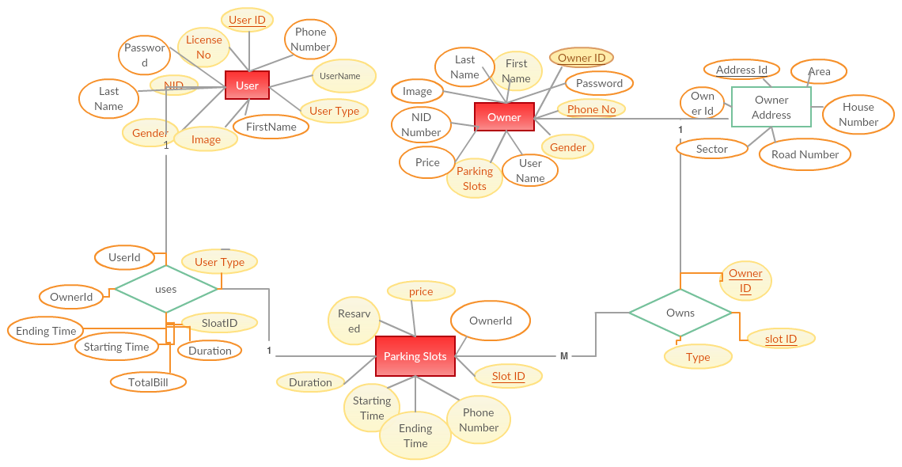

**Query Tables Construction**

CREATE TABLE Users(

UserID int IDENTITY(1001,1) NOT NULL PRIMARY KEY ,

UserName varchar (50) NOT NULL,

FirstName varchar (50) NOT NULL,

LastName varchar (50) NOT NULL,

Password varchar (50) Not Null,

PhoneNumber varchar (50) NOT NULL,

LicenceNumber varchar (50) NOT NULL,

NIDNumber varchar (50) not null,

Gender varchar (10) not null,

UserType varchar (50) not null,

Images image not null,

);

ALTER TABLE Users ADD UNIQUE(PhoneNumber);

CREATE TABLE Owner(

OwnerId int IDENTITY(2001,1) NOT NULL PRIMARY KEY,

UserName varchar (50) NOT NULL,

FirstName varchar (50) NOT NULL,

LastName varchar (50) NOT NULL,

Password varchar (50) Not Null,

PhoneNumber varchar (50) NOT NULL,

NIDNumber varchar (50) not null,

Gender varchar (10) not null,

ParkingSlots int NOT NULL,

Price int not null,

Images image not null

);

ALTER TABLE Owner ADD UNIQUE(PhoneNumber);

CREATE TABLE OwnersAddress(

OwnerId int NOT NULL FOREIGN KEY REFERENCES Owner(OwnerId),

AddressId int IDENTITY(3001,1) PRIMARY KEY NOT NULL ,

Area VARCHAR(50) NOT NULL,

Sector VARCHAR(50) NOT NULL,

RodeNumber VARCHAR(50) NOT NULL,

HouseNumber VARCHAR(50) NOT NULL

);

CREATE TABLE ParkingSlot(

OwnerId int NOT NULL FOREIGN KEY REFERENCES Owner(OwnerId),

SloatId int IDENTITY(4001,1) PRIMARY KEY NOT NULL,

PhoneNmber varchar(11) not null,

StartingTime varchar(50) null,

Duration varchar(10) null,

Reserved int not null,

Price decimal null,

);

ALTER TABLE ParkingSlot

ADD EndingTime varchar(50) null;

ALTER TABLE ParkingSlot

ADD TotalBill decimal null;

CREATE TABLE Uses(

SloatId int NOT NULL FOREIGN KEY REFERENCES ParkingSlot(SloatId) ,

UserID int NOT NULL FOREIGN KEY REFERENCES Users(UserID),

OwnerId int NOT NULL FOREIGN KEY REFERENCES Owner(OwnerId),

StartingTime varchar(50) null,

EndingTime varchar(50) null,

Duration int null,

TotalBill decimal null

);

**Query Insertion of Data**

**Java Code For Insert DataBase :**

String query = "insert into Users(UserName,FirstName,LastName,Password,PhoneNumber,LicenceNumber,NIDNumber,Gender,UserType,Images)values(?,?,?,?,?,?,?,?,?,?)";

String query = "insert into Owner(UserName,FirstName,LastName,Password,PhoneNumber,NIDNumber,Gender,ParkingSlots,Price,Images)values(?,?,?,?,?,?,?,?,?,?)";

String query = "insert into OwnersAddress(OwnerId,Area,Sector,RodeNumber,HouseNumber)values(?,?,?,?,?)";

String query = "insert into ParkingSlot(OwnerId,PhoneNmber,StartingTime,Duration,Reserved,Price)values(?,?,?,?,?,?)";

String query = "insert into Uses(SloatId,UserID,OwnerId,StartingTime,EndingTime,Duration,TotalBill)values(?,?,?,?,?,?,?)";

String str = "Select Owner.FirstName,Uses.StartingTime ,Uses.EndingTime,Uses.Duration,Uses.TotalBill from Uses full join Owner on Owner.OwnerId = Uses.OwnerId where Uses.UserID = ?";

**Query for Value Update, Setting Constraints and Rules**

String query = "update ParkingSlot set StartingTime = ? ,EndingTime = ? ,Duration = ? ,Reserved = 1, TotalBill = ? where PhoneNmber = "+value;

String query = "update Users set FirstName = ?,LastName = ?,Password = ?,UserType = ? where UserID = "+UserId;

ALTER TABLE Owner ADD UNIQUE(PhoneNumber);

ALTER TABLE Owner ADD UNIQUE( UserName);

ALTER TABLE Users ADD UNIQUE(PhoneNumber);

ALTER TABLE Users ADD UNIQUE( UserName);

**Query for the Join and Binary Operation ( like Union,except) you have used**

String sql = "Select * from Owner full join OwnersAddress on Owner.OwnerId = OwnersAddress.OwnerId where Owner.UserName = ? and Password = ?";

String query = "select Owner.PhoneNumber,Owner.FirstName,Owner.Price,OwnersAddress.Area,OwnersAddress.Sector,OwnersAddress.RodeNumber,OwnersAddress.HouseNumber from Owner full join OwnersAddress on Owner.OwnerId = OwnersAddress.OwnerId where OwnersAddress.Area = ? and OwnersAddress.Sector = ? and OwnersAddress.RodeNumber = ? and Owner.OwnerId in (select OwnerId from ParkingSlot where Reserved = 0)";

String str = "Select Owner.FirstName,Uses.StartingTime ,Uses.EndingTime,Uses.Duration,Uses.TotalBill from Uses full join Owner on Owner.OwnerId = Uses.OwnerId where Uses.UserID = ?";

SELECT OwnersAddress.OwnerId,AddressId,Area,Sector,RodeNumber,HouseNumber FROM OwnersAddress LEFT JOIN Owner ON OwnersAddress.OwnerId = Owner.OwnerId;

**Query that you have used by the form of sub query**

String query = "select Owner.PhoneNumber,Owner.FirstName,Owner.Price,OwnersAddress.Area,OwnersAddress.Sector,OwnersAddress.RodeNumber,OwnersAddress.HouseNumber from Owner full join OwnersAddress on Owner.OwnerId = OwnersAddress.OwnerId where OwnersAddress.Area = ? and OwnersAddress.Sector = ? and OwnersAddress.RodeNumber = ? and Owner.OwnerId in (select OwnerId from ParkingSlot where Reserved = 0)";

**Screen Shots of your project interface design**

|  |
| --- |
|  |
| **Image 01: Starting Page** |
|  |
| **Image 02: User & Owner SignIn & SignUp Page** |

**Image 03: User SignUp Page**

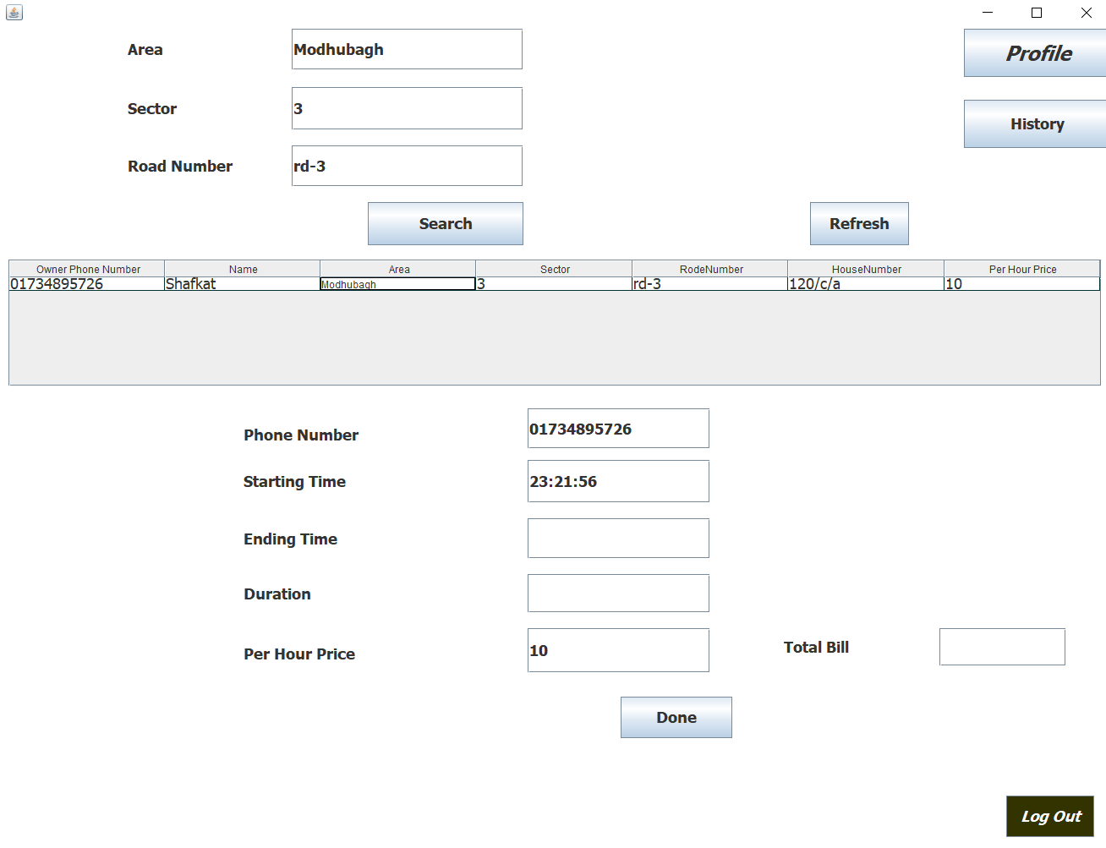

**Image 04: User HomePage**

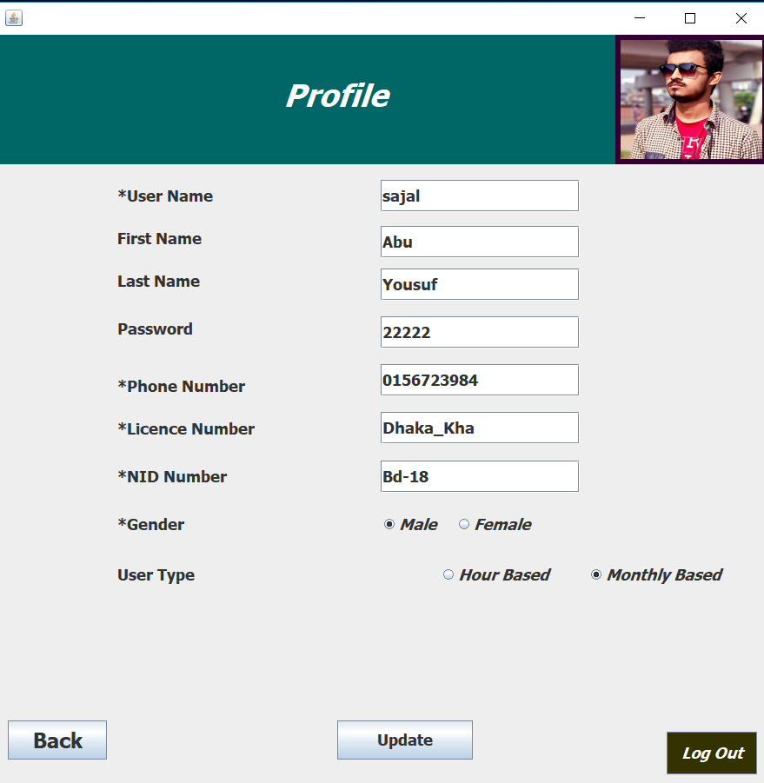

**Image 05: User Profile**

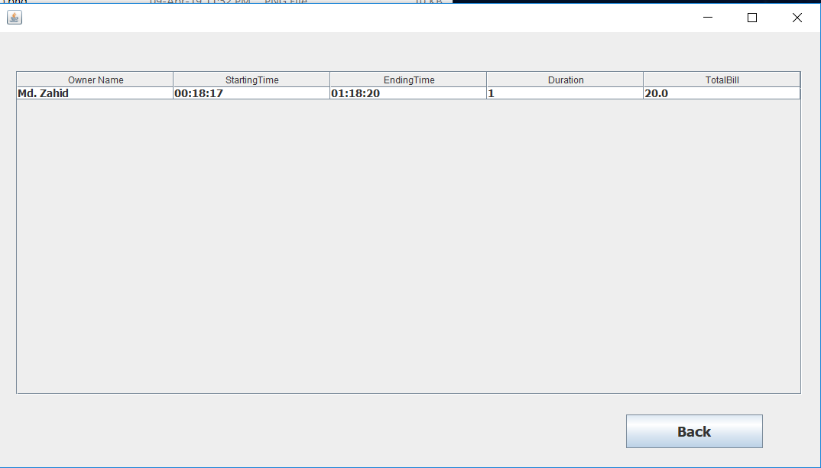

**Image 06: User History**

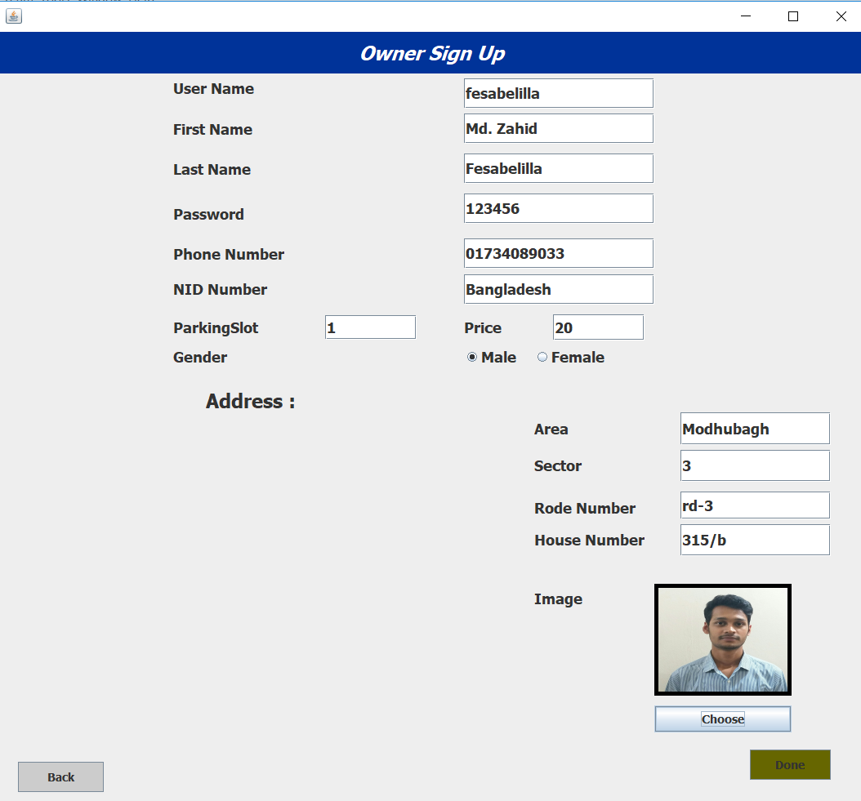

**Image 07: Owner SignUp Page**

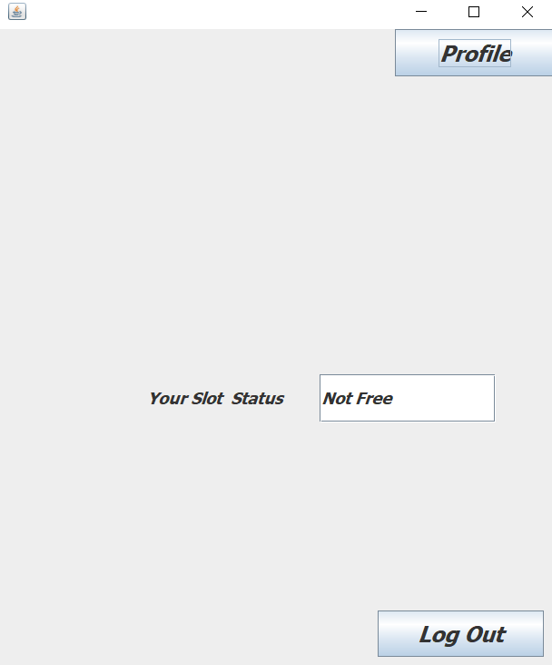

**Image 08: Owner Slot Status**

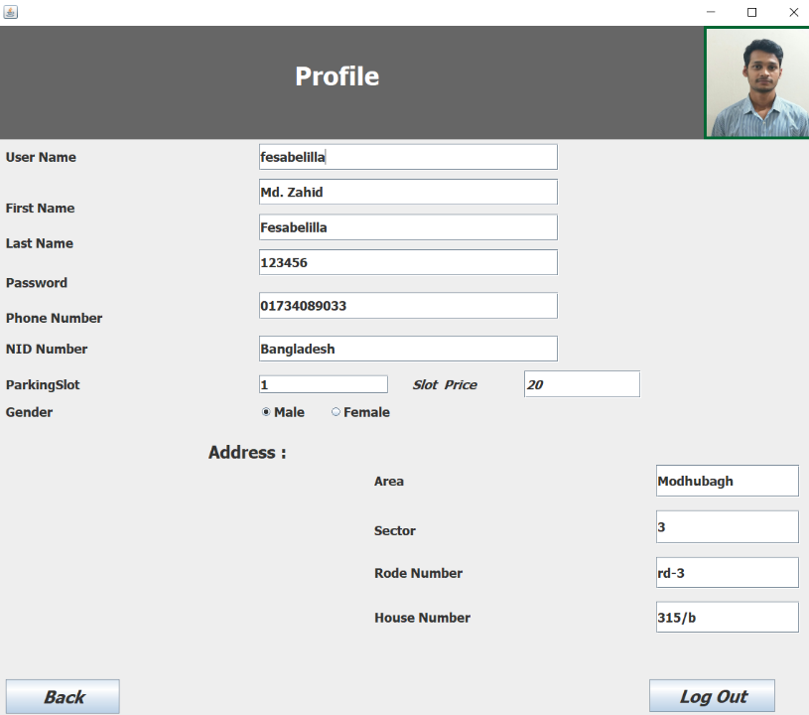

**Image 09: Owner Profile**

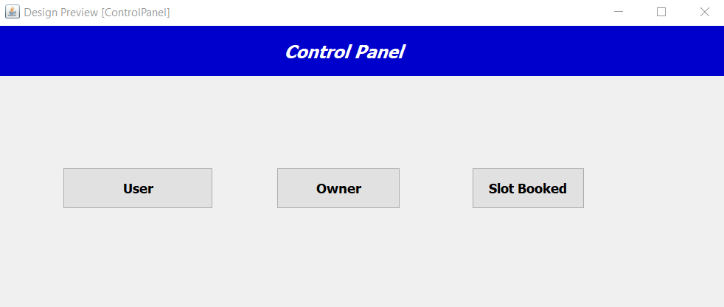

**Image 10: Control Panel**

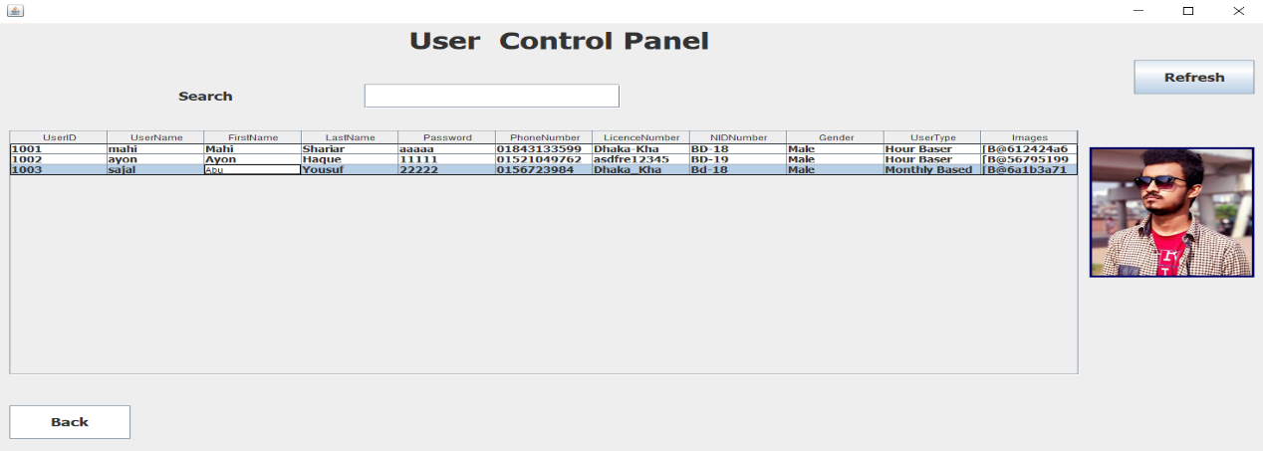

**Image 11: User Control Panel**

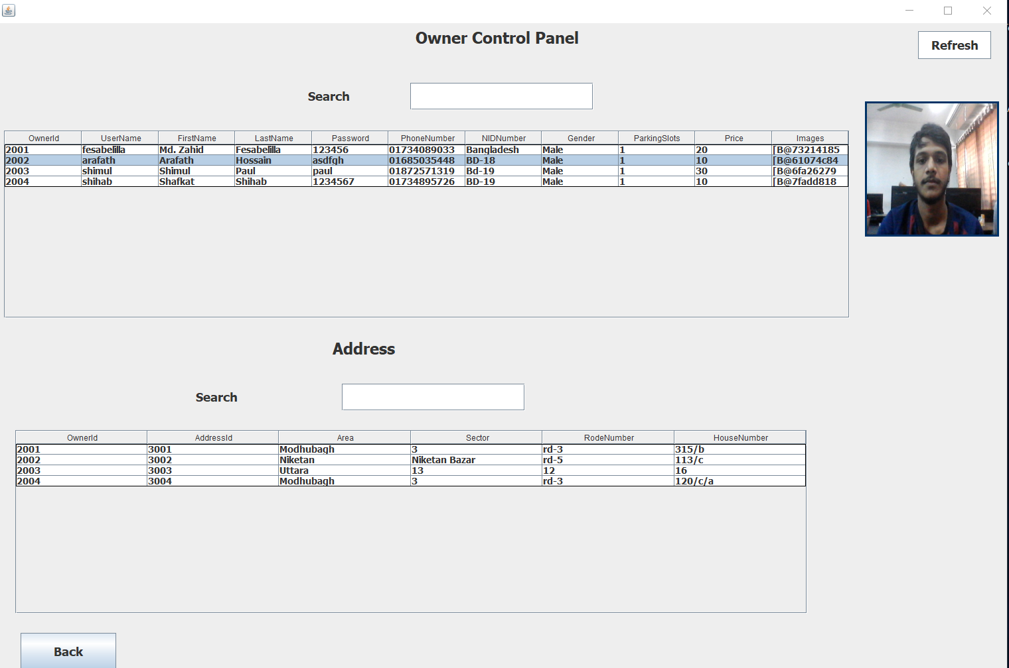

**Image 12:Owner Control Panel**

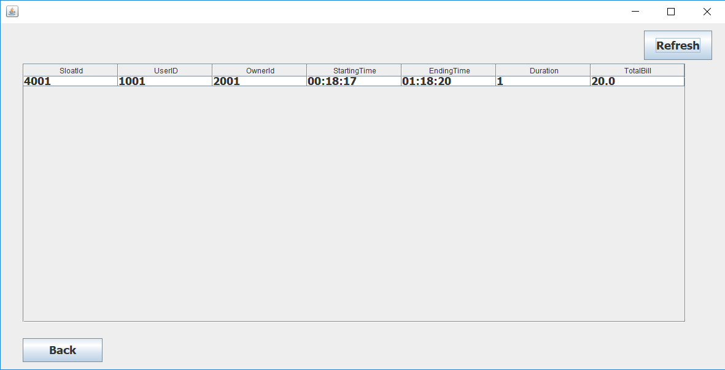

**Image 13: Booking History**

**Conclusion:**

This software will help the drivers to find quickly a suitable parking slot for his vehicle. It will also help the owners to make money from their unused spaces in their house. Moreover this software will move the vehicles from the road that will remain stop for a while and thus keeping the roads free from stopped vehicles. This software will help the traffic system as it reduces the number of vehicles in the roads.

**Contribution:**